Revision worksheet 1

1. Implicit-

Explicit-

1. startActivity()-

startActivityForResult()-

1. Explain the following-

Intent i = new Intent(this, ActivityTwo.class);

i.putExtra("Value1", "This value one for ActivityTwo ");

i.putExtra("Value2", "This value two ActivityTwo");

1. What is shared preferences
2. Complete the following 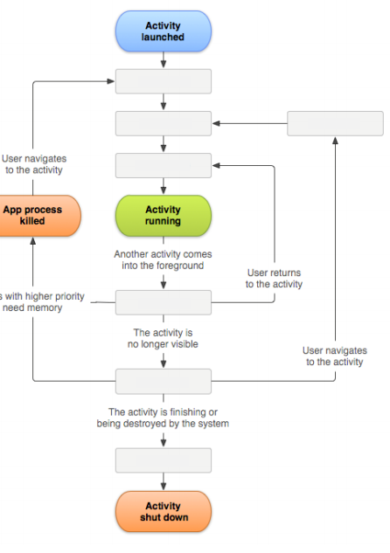

6. Describe the following code:

Bundle extras = getIntent().getExtras();

if (extras == null) {

return;

}

// get data via the key

String value1 = extras.getString(Intent.EXTRA_TEXT);

if (value1 != null) {

// do something with the data

}

7. Create an Android Application with one activity with one button. On Click the button should run the following code:

String url = "http://www.vogella.com"; Intent i = new Intent(Intent.ACTION_VIEW); i.setData(Uri.parse(url)); startActivity(i);

1. This is an:

[ ] Implicit Intent

[ ] Explicit Intent

b. Describe the code above